**Low Level Design Document**

Mainframe Tour Project

Name: Kondreddy Sumanth Kumar Reddy  
**Mainframe ID:** OZA136  
Project Name: Mainframe Project on Tour

**TABLE OF CONTENTS**

1.Requirement Summary 3

2. Component List 3

2.1 Database Components 3

2.1.1 TOUR_DETAILS 4

2.1.2 SEASON_DISCOUNT 4

2.2 SPUFI Components 5

2.3 COBOL Program Components 5

2.4 JCL Components 5

2.5 Output Files 6

3. Flowchart 6

4. Pseudo Code 8

4. Test Cases 8

6. Version History 9

## 1.Requirement Summary

The Tour Details System is responsible for managing tour records in the TOUR_DETAILS database. It ensures data is read, updated, and maintained efficiently. The system performs the following operations:

* Create tables (TOUR_DETAILS, SEASON_DISCOUNT) using SPUFI.
* Insert sample values into TOUR_DETAILS.
* Fetch relevant records using a cursor.
* Handle null values in TOUR_GUIDE and write to an output file.
* Delete records with null TOUR_GUIDE.
* Compute DISCOUNT, FINAL_PRICE, and GROUP_DISCOUNT based on rules.
* Insert processed records into SEASON_DISCOUNT.
* Write output records into designated files.
* Write SPUFI queries to fetch required records using LEFT OUTER JOIN and conditional filtering.

## Component List

The system consists of multiple components, categorized into database, SPUFI queries, COBOL programs, JCL scripts, and files. Each component plays a crucial role in processing and managing the tour details efficiently.

### 2.1 Database Components

The database is the core storage unit for all tour-related information. It consists of tables that store tour details and seasonal discount calculations.

|  |  |  |  |
| --- | --- | --- | --- |
| **Component Type** | **Component Name** | **Description** | **Input/Output** |
| Table | TOUR_DETAILS | Stores tour-related details. Fields include:  TOUR_ID, TOUR_PLACE, TOUR_GUIDE, LANGUAGE, TOUR_DATE, GROUP_SIZE, PRICE_PER_HEAD. | Input / Output |
| Table | SEASON_DISCOUNT | Stores computed discounts and pricing. Fields include:  TOUR_PLACE, TOUR_GUIDE, TOUR_DATE, DISCOUNT, FINAL_PRICE, GROUP_DISCOUNT. | Output |

### 2.1.1 TOUR_DETAILS

* Stores tour information including tour ID, place, guide, language, date, group size, and price per head.
* Purpose INPUT/OUTPUT.
* SPUFI member TABLE1 to create the table.
* SPUFI member INSERT1 to insert sample data.

Table Description:

|  |  |  |  |
| --- | --- | --- | --- |
| **Column Name** | **Data Type** | **Constraints** | **Description** |
| TOUR_ID | CHAR(5) | PRIMARY KEY | Unique identifier for the tour |
| TOUR_ID | VARCHAR(30) | NOT NULL | Describes the tour destination |
| TOUR_GUIDE | VARCHAR(30) | NULL | Name of the tour guide |
| LANGUAGE | CHAR(3) | NOT NULL | Language used for the tour |
| TOUR_DATE | DATE | NOT NULL | Date of the tour |
| GROUP_SIZE | INTEGER | NOT NULL | Number of participants |
| PRICE_PER_HEAD | INTEGER | NOT NULL | Price per person |

### 2.1.2 SEASON_DISCOUNT

* Stores calculated discount information based on tour details.
* Purpose OUTPUT.
* SPUFI member TABLE2 to create the table.

Table Description:

|  |  |  |  |
| --- | --- | --- | --- |
| **Column Name** | **Data Type** | **Constraints** | **Constraints** |
| TOUR_PLACE | VARCHAR(30) | NOT NULL | Describes the tour destination |
| TOUR_GUIDE | VARCHAR(30) | NULL | Name of the tour guide |
| DATE | DATE | NOT NULL | Date of the tour |
| DISCOUNT | INTEGER | NOT NULL | Calculated discount percentage |
| FINAL_PRICE | INTEGER | NOT NULL | Final price after discount |
| GROUP_DISCOUNT | INTEGER | NOT NULL | Group discount applied |

### 2.2 SPUFI Components

SPUFI (SQL Processing Using File Input) queries are used for table creation, data insertion, and fetching specific records from the database. These queries automate interactions with DB2 tables.

|  |  |  |
| --- | --- | --- |
| **Component Type** | **Component Name** | **Description** |
| SPUFI Member | TABLE1 | Creates the TOUR_DETAILS table. |
| SPUFI Member | TABLE2 | Creates the SEASON_DISCOUNT table. |
| SPUFI Member | INSERT1 | Inserts sample data into TOUR_DETAILS. |
| SPUFI Member | JOIN | Perform a LEFT OUTER JOIN between the TOUR_DETAILS and SEASON_DISCOUNT tables, filtering results where LANGUAGE is 'ENG' and GROUP_SIZE > 10. |
| SPUFI Member | SELECT | Retrieve records from SEASON_DISCOUNT where the DISCOUNT <= 20, ensuring relevant fields are converted to lowercase. |

### 2.3 COBOL Program Components

The COBOL program processes tour details by fetching, validating, computing, and storing results in database tables and files. It is responsible for managing the core business logic of the system.

|  |  |  |
| --- | --- | --- |
| **Component Type** | **Component Name** | **Description** |
| COBOL Program | TOUR | Reads TOUR_DETAILS, processes data, and inserts into SEASON_DISCOUNT. |
| DCLGEN | TOURDET | Declaration generator for the TOUR_DETAILS table, providing COBOL data structures. |
| DCLGEN | SEASDIS | Declaration generator for the SEASON_DISCOUNT table, providing COBOL data structures. |

### 2.4 JCL Components

JCL (Job Control Language) scripts are used to compile and execute the COBOL program.

|  |  |
| --- | --- |
| **Component Name** | **Description** |
| CBLDBCMP | **Compile:** Converts COBOL+DB2 code  into an executable module. |
| CBLDBBND | **Bind:** DB2 prepares & optimizes SQL path and creates package or plan for execution. |
| CBLDBRUN | Run: Executes the compiled program, interacting with DB2 using the bound plan/package. |

### 2.5 Output Files

The system utilizes external files to store processed tour details.

|  |  |  |  |  |
| --- | --- | --- | --- | --- |
| **File Name** | **DD Name** | **Record Length** | **Description** | **Input/Output** |
| OZA136.SUMANTH.TOUR.PS | OUTTOUR | 80 | Output file for processed records with discount information. | Output |
| OZA136.SUMANTH.ODEL.PS | OUTODEL | 80 | Output file for with null TOUR_GUIDE values. | Output |

## Flowchart

• **Start**: The program begins execution.

• **Initialize Variables**: The program initializes necessary variables (e.g., WS-END-OF-CURSOR, working storage areas for tour details, discounts, etc.).

• **Declare and Open the Cursor**: The program declares and opens the TOUR-CURSOR to fetch records from the TOUR_DETAILS table.

• **Fetch record from Tour_Details**: The program fetches a record from the TOUR_DETAILS table using the cursor.

• **Decision - End of records?**: The program checks if the end of records has been reached (SQLCODE = 100).

* If **Yes** (End of records):
  + **Close Cursor**: Closes the TOUR-CURSOR.
  + **End Program**: The program terminates.
* If **No** (Records available):
  + Next Step: Decision - Is TOUR_GUIDE NULL?

• **Decision - Is TOUR_GUIDE NULL?**: The program checks if the TOUR_GUIDE field is NULL or empty.

* If **Yes** (TOUR_GUIDE is NULL):
  + **Move 'YTD' to TOUR_GUIDE**: Sets the TOUR_GUIDE to 'YTD'
  + **Write record to OUTODEL**: Writes the record with the NULL guide to the OUTODEL file.
  + **Delete record from TOUR_DETAILS**: Deletes the record from the TOUR_DETAILS table.
* If **No** (TOUR_GUIDE is not NULL):

• **Compute DISCOUNT, Compute FINAL_PRICE, Compute GROUP_DISCOUNT**: The program calculates the discount, final price, and group discount based on the group size and language.

• **Insert into SEASON_DISCOUNT**: Inserts the processed record (with calculated values) into the SEASON_DISCOUNT table.

• **Write record to OUTTOUR**: Writes the processed record to the OUTTOUR file.

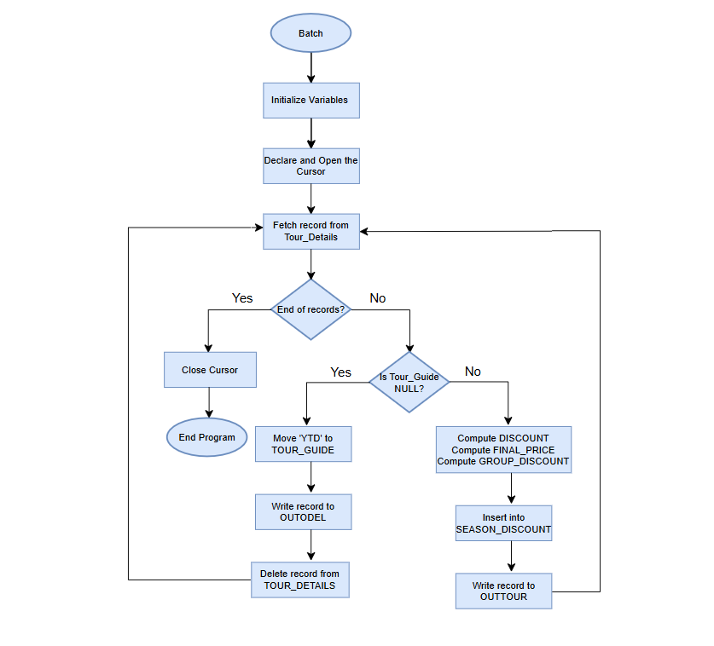

## 4. Pseudo Code

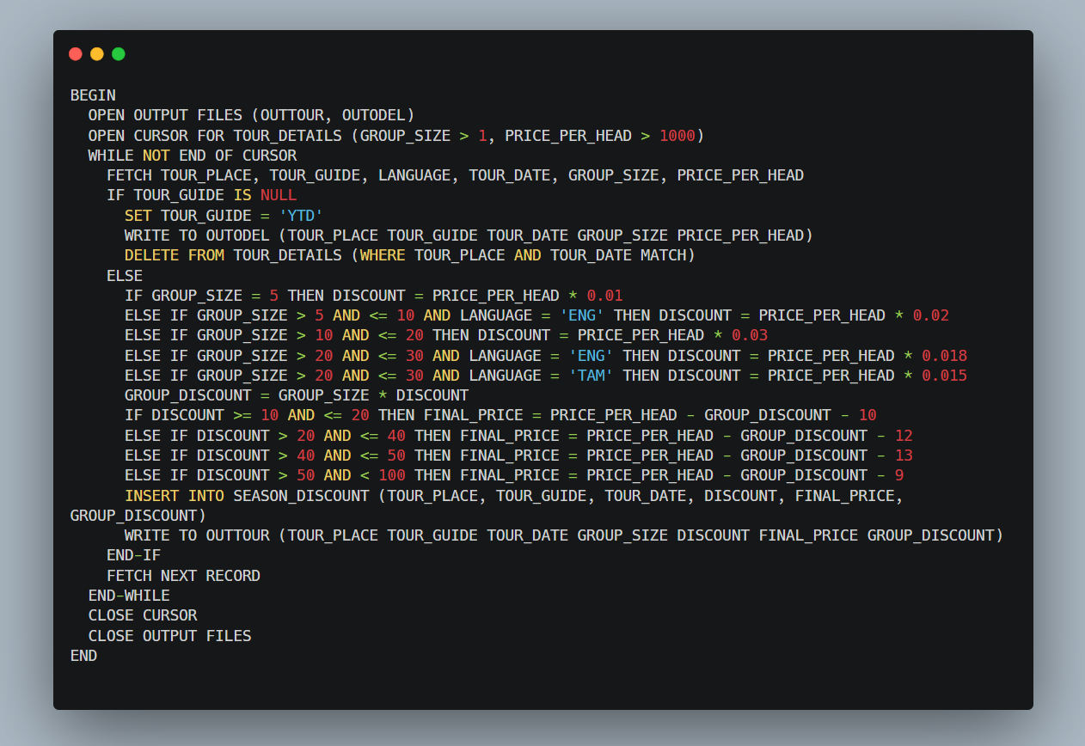

## Test Cases

|  |  |  |
| --- | --- | --- |
| **Test Case ID** | **Test Case Description** | **Status (Pass/Fail)** |
| TC01 | Verify the creation of the TOUR_DETAILS table with the correct column definitions. | PASS |
| TC02 | Verify the creation of the SEASON_DISCOUNT table with the correct column definitions. | PASS |
| TC03 | Insert sample data into the TOUR_DETAILS table. | PASS |
| TC04 | Handle records where the TOUR_GUIDE field contains NULL values. | PASS |
| TC05 | Compute the discount for GROUP_SIZE = 5. | PASS |
| TC06 | Compute the discount for GROUP_SIZE between 6 and 10, filtering by LANGUAGE = "ENG". | PASS |
| TC07 | Determine the FINAL_PRICE for discounts ranging between 41 and 50. | PASS |
| TC08 | Determine the FINAL_PRICE for discounts ranging between 51 and 99. | PASS |

## 6. Version History

|  |  |  |  |
| --- | --- | --- | --- |
| **Version** | **Date** | **Author** | **Changes Made** |
| 1.0 | 17-03-2025 | Sumanth Kumar Reddy | Initial draft created. |
| 1.1 | 18-03-2025 | Sumanth Kumar Reddy | Added Pseudo and test cases. |
| 1.2 | 19-03-2025 | Pranchan Biswas | Signed-off and final review. |